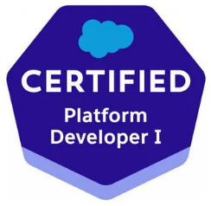
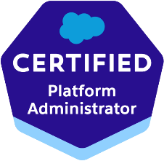
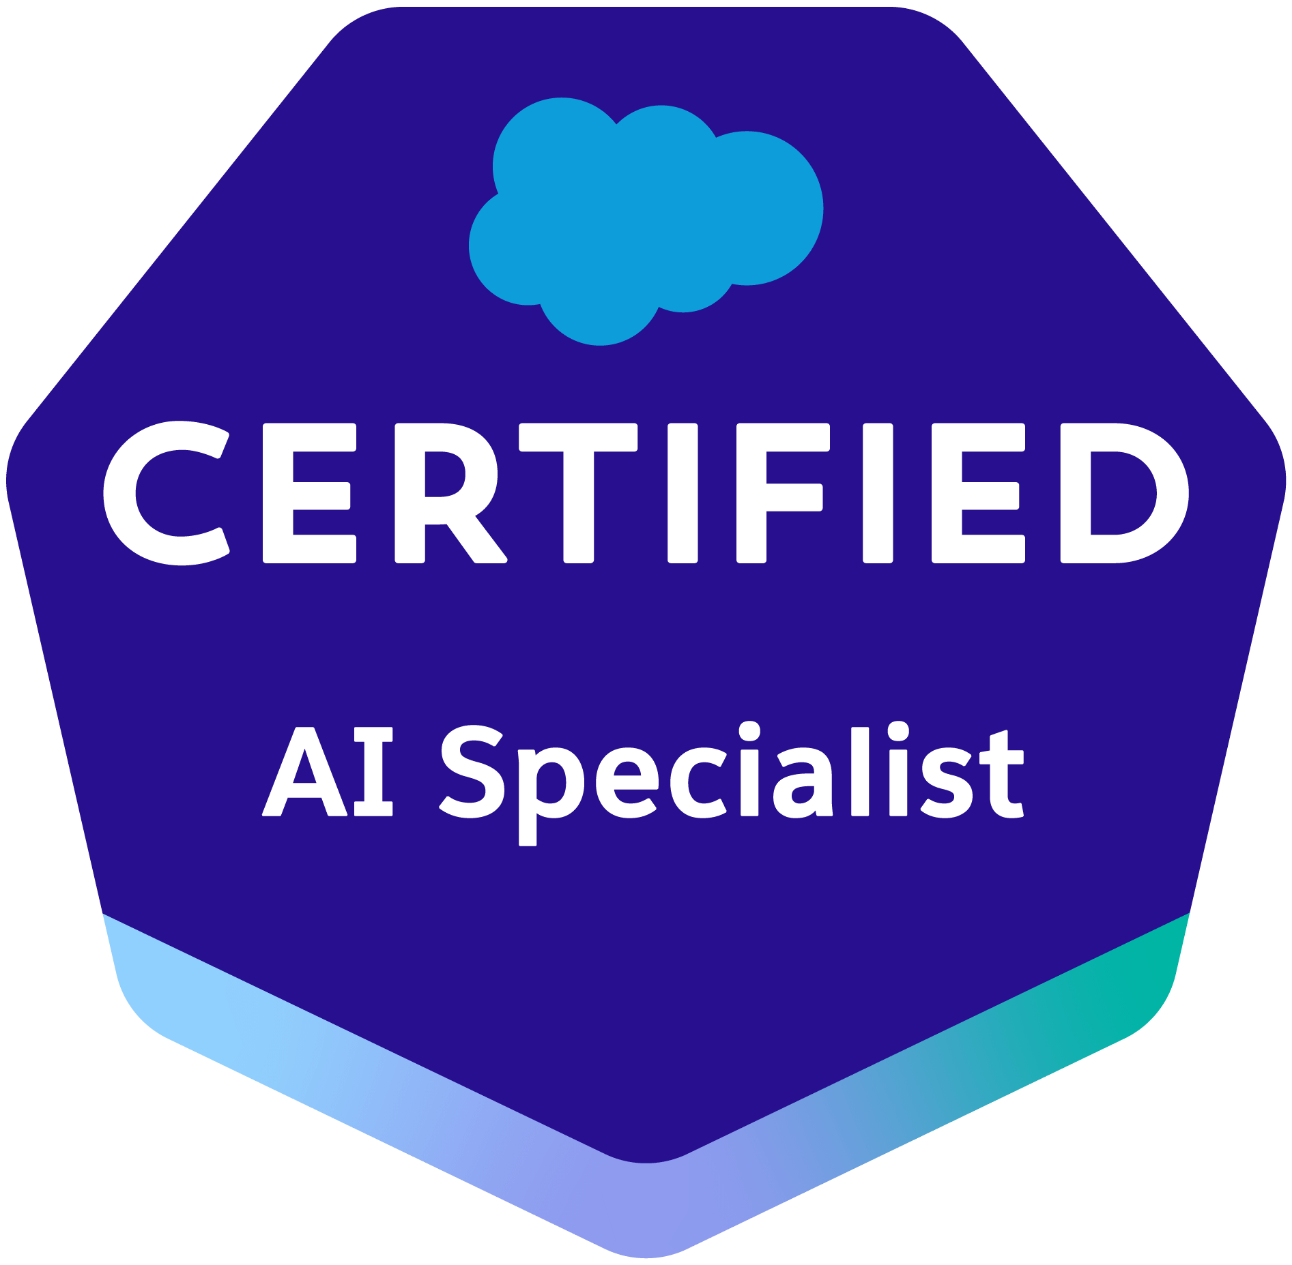

SURYA N
Salesforce Lightning Developer
Email: nsurya.dx@gmail.com | Phone: +91-9618519285 |
LinkedIn: www.linkedin.com/in/surya-chandra-neelagiri-242119306
Location: Hyderabad, India
PROFESSIONAL SUMMARY

A Salesforce Developer with 4+ years of hands-on experience in designing, developing, and deploying custom solutions on the Salesforce platform. Proficient in Salesforce Lightning (Aura & LWC), with deep functional and technical expertise across Sales Cloud, Service Cloud, and Experience Cloud. Brings strong Experience Cloud specialization, having architected customer and partner portals end-to-end. Skilled in Salesforce CPQ with focused exposure in product configuration, pricing rules, quote templates, and order management to support complex quote-to-cash processes. Experienced in third-party integrations using REST/SOAP APIs, sales operations optimization, and end-to-end deployment management across multiple environments. Adept at collaborating with cross-functional teams and delivering scalable, high-quality CRM solutions for enterprise clients.
TECHNICAL SKILLS

Salesforce Clouds | Sales Cloud, Service Cloud, Experience Cloud, Order Management, community cloud
Development | Apex (Classes, Triggers, Batch, Schedulable, Queueable), Visualforce, Lightning Aura Components, Lightning Web Components (LWC)
Salesforce CPQ | Product Bundles, Product Rules, Price Rules, Discount Schedules, Quote Templates, Approval Workflows, Guided Selling
Declarative Tools | Flows (Screen, Record-Triggered, Scheduled), Process Builder, Validation Rules, Workflow Rules, Approval Processes
Integration | REST API, SOAP API, Outbound Messages, Connected Apps, Named Credentials, Platform Events, Callouts
Data Management | Data Loader, Import Wizard, Duplicate Management, VLOOKUP Matching
Deployment & DevOps | Change Sets, Salesforce CLI (SFDX), ANT Migration Tool, VS Code, Git, CI/CD Pipelines
Security | Profiles, Permission Sets, Role Hierarchy, OWD, Sharing Rules, Field-Level Security
Reporting | Reports, Dashboards, Custom Report Types, Cross Filters, Joined Reports
Other Tools | Jira, Confluence, Postman, Workbench, Developer Console, Debug Logs
PROFESSIONAL EXPERIENCE

SKALA Consultancy Services
Software Engineer | [May 2022] – Present
Client: Valmont Industries | Sales Cloud, Service Cloud, Experience Cloud |Duration: Feb 2024 – April 2026
Valmont is a global leader in engineered infrastructure and agricultural products. Played a key role in their Salesforce implementation across Sales Cloud, Service Cloud, and Experience Cloud, with primary focus on designing and delivering the customer and partner-facing Experience Cloud portal.
- Developed the Experience Cloud (Community) portal from the ground up, enabling customer and partner self-service for order tracking, case submission, knowledge articles, and account management.
- Built custom Lightning Web Components (LWC) for the Experience Cloud portal including dynamic dashboards, custom navigation menus, branded login pages, and interactive data tables.
- Configured audience-based page variations, guest user access controls, and custom themes to deliver personalized portal experiences for different partner tiers.
- Implemented CMS content management within Experience Cloud to enable marketing and support teams to publish knowledge articles, announcements, and resource documents.
- Developed Apex controllers and services to expose secure data to Experience Cloud components, enforcing sharing rules and CRUD/FLS compliance for portal users.
- Configured Sales Cloud modules including Leads, Opportunities, Accounts, Contacts, Products, and Price Books to support the inside sales team.
- Customized Service Cloud features including Case Management, Entitlements, and Milestones to support customer service workflows surfaced through the portal.
- Integrated Salesforce with external systems using REST API callouts and Connected Apps to synchronize account and order data in real time.
- Managed end-to-end deployments using Change Sets, Salesforce CLI (SFDX), and Git-based version control across multiple Sandbox and Production environments.
- Wrote comprehensive unit test classes achieving 85%+ code coverage and participated in code reviews, sprint planning, and Agile ceremonies.
Client: Pure Storage | Order Management, Sales Operations, Salesforce CPQ | Duration: June 2022 – March 2024
Pure Storage is a leading data storage company delivering flash-based solutions. Focused on Salesforce CPQ implementation, order management lifecycle, and sales operations optimization to support their complex product catalogue and global sales workflows.
- Implemented and configured Salesforce CPQ end-to-end, including Product Bundles, Product Rules, Price Rules, Discount Schedules, and multi-dimensional quoting for complex hardware and subscription pricing models.
- Designed and customized CPQ Quote Templates to generate branded, client-ready quote documents with dynamic line items, terms and conditions, and approval stamps.
- Built CPQ Approval Workflows with multi-level approval chains based on discount thresholds, deal size, and product categories to enforce pricing governance.
- Configured Order Management processes including Order creation from CPQ Quotes, Order activation, Order Products, and Contract generation to streamline the quote-to-cash lifecycle.
- Developed custom Apex Triggers and Batch Apex classes to automate order processing, renewal opportunities, and subscription management workflows.
- Optimized Sales Operations by configuring Opportunity Splits, Collaborative Forecasting, Territory Management, and Sales Path to improve pipeline visibility and rep efficiency.
- Built custom Lightning Web Components (LWC) for order summary dashboards, guided selling wizards, and sales rep productivity tools.
- Integrated Salesforce CPQ with external ERP and billing systems using REST API callouts and Platform Events to ensure real-time order and invoice synchronization.
- Designed and implemented Record-Triggered Flows and Scheduled Flows to automate order status updates, renewal reminders, and SLA-based escalation logic.
- Managed data migration of Products, Price Book Entries, and historical Orders using Data Loader, ensuring data integrity across environments.
- Performed deployments using Change Sets and SFDX, maintained version control with Git, and supported production releases with rollback strategies.
- Provided post-deployment production support, troubleshooting CPQ calculation issues, flow errors, and integration failures using Debug Logs and Workbench.

CERTIFICATIONS

- Salesforce Platform Developer I (Certified)
- Salesforce AI Associate (Certified)
- Salesforce AI Specialist (Certified)
- Salesforce Administrator (In Progress)
EDUCATION

Bachelor of Technology (B. Tech), Mech
[JNTU Kakinada]
DECLARATION

I hereby declare that all the information furnished above is true and correct to the best of my knowledge and belief. I bear the responsibility for the correctness of the above-mentioned particulars.

Place: Hyderabad
Date:
Surya N
(Signature)

